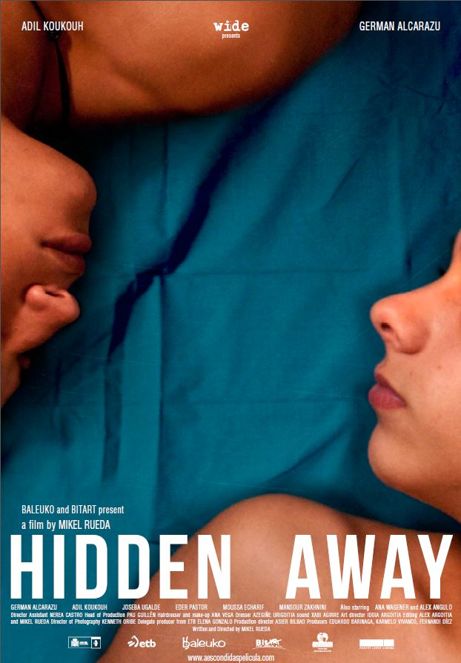
BALEUKO and BITART present

HIDDEN AWAY
A film by Mikel RUEDA
SHORT SYNOPSIS

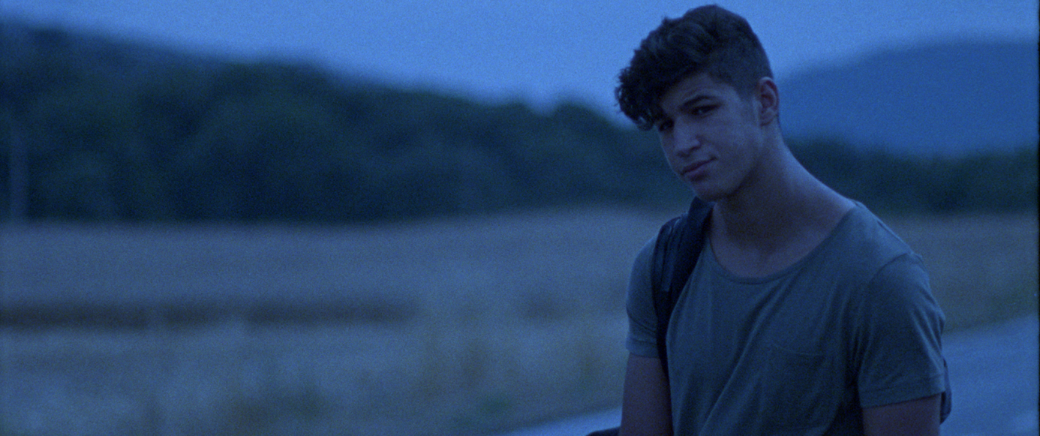
Ibrahim, a 14 year‐old Moroccan boy, walks down a road in the outskirts of a big city, alone and disoriented. He has just been informed that he will be deported in two days, so he has packed up and ran away. He is alone with no place to go. Rafa, a 14 years‐old Spanish boy, runs into a club toilet like a bundle of nerves. Outside, there is a girl, Marta, waiting for him. A girl who expects him, far more than what he can give. These two boys´ paths are about to cross.

LONG SYNOPSIS

Dawn breaks on a road in southern Spain. At ground level, at over 100k.p.h, a lorry speeds along the asphalt. We see, meter by meter, the road fly by. We are at the height of the lorry’s wheels, going faster. Meters turn into kilometers, and we are still there, watching the asphalt race by.

Ibrahim, a Moroccan boy of 14, walks alone and confused along a road on the outskirts of a large city.
He’s just been told that in two days he’ll be expelled from the country, so he’s taken his things and ran away. He has nowhere to go.

Rafa, a 14 year old boy from Spain, runs into a nightclub bathroom. He can’t take it anymore. He’s at breaking point. Outside we find Marta, a girl who expects more from him than he thinks he can give.

The lives of both of these boys are about to cross and it won’t be accidental. They will have a profound effect on each other. This meeting will make them start to feel things that neither will be able to control.

And so “Hidden Away” begins, a script narrated in the first person, with a very individual style, about friendship and love that arises between Ibrahim and Rafa. A story marked by Ibrahim’s situation in particular. As the story unfolds, we jump around in time (although here it is presented in chronological order), and we discover, little by little, who Ibrahim really is, realising that what at first may seem to be an animal is not so underneath.

Rafa and Ibrahim’s story won’t be told chronologically. Quite the contrary; it’ll be fragmented, jumping from present to past repeatedly (especially in the first third of the script), as it introduces us to characters who are totally lost. To two young teenage boys who don’t quite know what to do nor what to feel. This fragmented presentation will help us to put ourselves in their shoes. In the shoes of two fourteen-year-old kids who, out of the blue and without ever imagining it possible, find themselves in the middle of a love story. Theirs. Their first. A love story between two men at that. This logically makes them doubt about many things, not because they aren’t sure about what they feel, but because society makes them question it all. The boys are happy living their romance on the fringes, “hidden” from the rest of the world. They encounter trouble when they have to face real life.

Let’s start with the beginning, in order, so that we can see the big picture. Let’s start by familiarizing us with what this story has in store for us.

We will get to know Ibrahim, a boy who came to Spain 4 years before, looking for a better future, and after moving from shelter to shelter, has finally settled in a small city in northern Spain. Ibrahim only wants one thing-a place to stay with the right papers to keep him in the first world. And every day he gets closer to his goal. Going against what we might think at the beginning, Ibrahim, before receiving his deportation order, was perfectly integrated into society. He went to class every day. Then he attended classes to improve his already fluent Spanish, and even played in a football team.

But fate has played a trick on him. Without knowing why, the government has decided to extradite him, and Ibrahim sees no option but to run away. At this point he meets Youssef, another Moroccan boy who survives thanks to the pockets he picks. Ibrahim will soon see that not all who leave his country in search of a better future have found it

Given that he as now submerged in that new world, he will have to sort things out to fit in as quickly as possible.

On the other hand, there is Rafa. A 14 year old Spaniard who lives a pretty normal life. Like most boys his age, Rafa goes to school, goes out with his friends, has a place where they can smoke and drink without being bothered, and of course plays in a football team. Rafa doesn’t realize, or doesn’t want to, that the girls in their group have started to notice him, which makes him more and more nervous. He doesn’t know how to react, and this makes him insecure.

The lives of these two characters run parallel to one another, as in most of the lives we encounter every day in the street. And, though we aren’t aware of it, life..Or lives pass us by every second, at every moment; each one with a different story behind them, and we don’t see. And Rafa and Ibrahim have crossed paths and never realized it.

Until one day, when both of them decide to go to a local nightclub to have some fun. Here is where the stories of our characters will come together for the first time.

The next encounter will be somewhat more competitive. A football match. Stemming from these two encounters, their worlds-so different to each other-will start to intertwine. There is something that unites all human beings: their feelings. Everyone feels, and Rafa and Ibrahim are no different.

Ibrahim, who up to now had rejected having friends in the city as he thought they would have to be separated sooner or later, has now found a good friend. A true friend. Although neither of them is aware of it yet, their friendship is growing in a way neither could imagine.

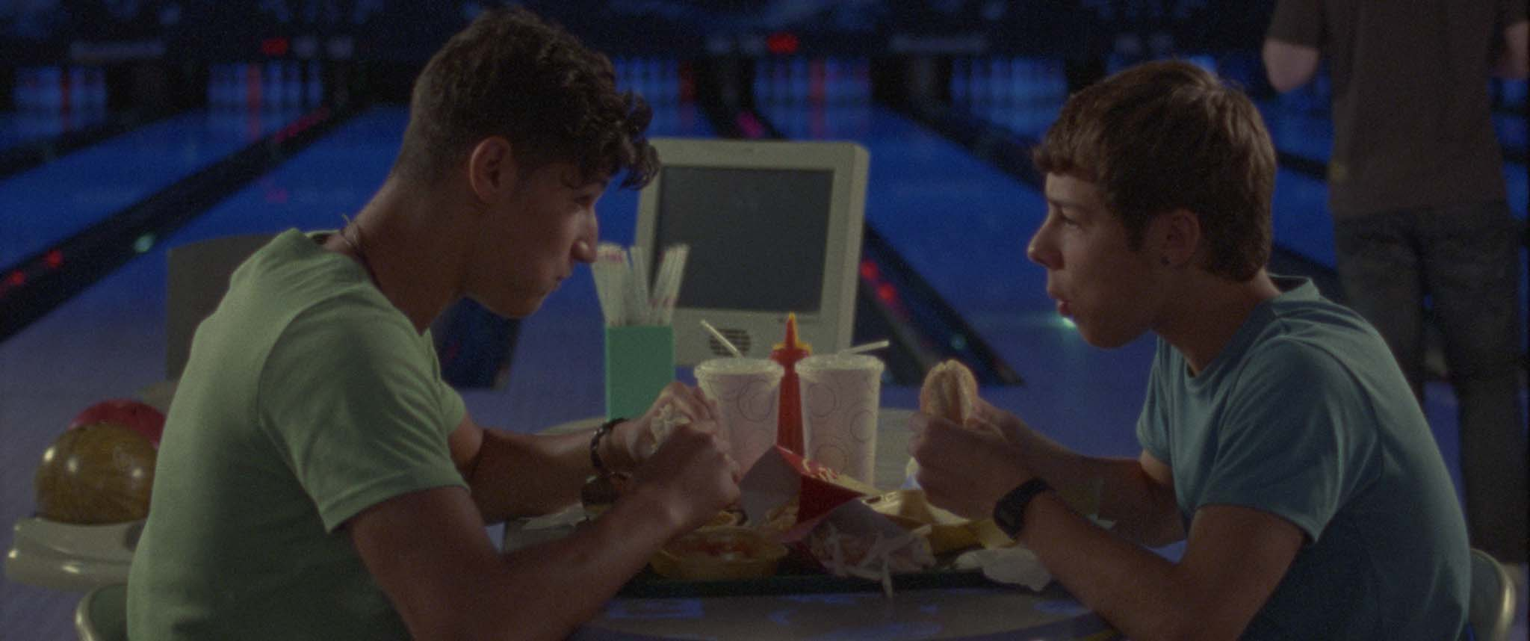
Ibrahim and Rafa will start spending more and more time together. They’ll hide from the world to live their story. Theirs. The one they want to live, not the one others would have them live. They’ll both follow their feelings… their emotions… and they’ll have no qualms about demonstrating it to the each other. Because when you feel it, when it’s real… and especially when it’s your first time and there’s no one to judge you, you go with the flow. You go with what you’re feeling and with what’s taking place… forgetting about the rest. This is what happens to both Ibrahim and Rafa. They’ll forget about the outside world, living their story and enjoying it, “in hiding”.

But life sets us back when we least expect it, and when all seems calm, Ibrahim receives the letter from the Ministry Of Justice warning him he’ll be deported to his own country in two days, alleging a supposed family reunion. Ibrahim doesn’t believe it, making the most drastic decision-to run away from the shelter.

From this moment, and with the encounter with Youssef, Ibrahim’s life will be hell. Drug dealing. Petty larceny. Youssef’s screams. Running from the police. Ibrahim, who had been perfectly integrated, has become a boy from The Street.

To make matters worse, he breaks up with the only person who’s given him self-confidence. From the person he’s fiercely attracted to, without really understanding why, and who makes him feel good. He breaks up with Rafa.

For Rafa, he’ll do all he can to find his friend, but to no avail. It appears that the city, which can seem so small to us, had swallowed up his best friend. And with it, his heart.

Rafa has lost his spirit, and has no will to do anything. He had started to feel something special for Ibrahim, but in a flash, Ibrahim had vanished.

Many of Rafa’s friends will try to rescue him from his particular odyssey into the wilderness, but none will succeed. Rafa feels an immense emptiness inside and nothing nor any one seem able to help him free himself from this state of mind.

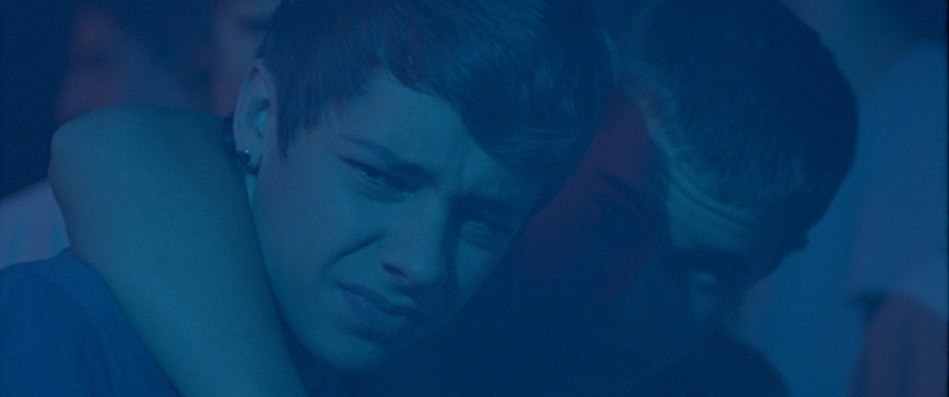
All will change one Easter afternoon. Rafa is basically forced by Guille (one of his friends) to go buy hashish on the streets. There’s no hash left in the hangout where they usually spend their afternoons and it’s been decided that Rafa and Guille are the ones who will go get more hash.

There, in a dark alley, Ibrahim and Rafa meet again. Having no other choice under the circumstances and the misunderstanding, they run away together. What’s more, their time apart has made them realize what they feel about each other. And naturally…they kiss. They kiss because they are happy together, because they can’t comprehend life without each other…this may seem excessive to you…but at 14…everything seems so important…and even more so if it’s your first love. For them it is. So they live it like it was their last.

Rafa and Ibra don’t know what to do. They’re with each other and they don’t need anything else. But something is preventing Ibrahim from enjoying this moment. If they don’t find a solution quickly, they’ll soon be caught and he’ll be deported to his country. What’s worse isn’t that they’ll kick him out the country he’s spent the last four years in, where he’s perfectly integrated. No, the worst thing is losing Rafa, which he doesn’t want to do under any circumstance. He doesn’t want that to happen because he’s finally happy, having at last met someone who understands him and makes him feel special. That’s why he’s so sad. Rafa notices and tries to convince him to act together. And that’s what they do, with conviction, knowing that “together”, they’ll be able to overcome anything..

From now on, various things happen to them. They ask “Adults” for help, but not with the expected results. So they run away again. They will spend the night in an abandoned coach…without knowing what they’ll do the next day…but not caring so much about that, because they are together…and that’s all they need at that moment.
But everything starts to unravel all at once and they can’t do anything about it. Youssef comes out of nowhere and he basically forces them to help him flee the country. They don’t quite know what to do. Anyhow, Youssef doesn’t give them a choice. Because of Ibra, Youssef’s “organization” has been dismantled and the only thing he can do now is flee the country to France. So Ibra and Rafa will help Youssef and his brother climb into a freight train departing tonight and then they’ll be able to leave. They owe it to Youssef.

So, with little time to think, our two leads find themselves running along the tracks, at night, trying to get onto a moving train. As things don’t always turn out well, Rafa trips and falls. He can’t follow them. And, worse, some cops are running towards the train at full speed, having realized what’s going on.
Ibrahim must choose: Go with Youssef for a better future or stay with Rafa, with no idea of what the future may bring. But Ibrahim knows. He’ll stay. In the distance, the police draw closer. Rafa and Ibrahim know what this means. They embrace. They know they’ll be separated. Again. This time, however, it may be forever.

Rafa and Ibrahim have lived their story on the fringes, their way. Without caring about what was going on around them. But life has shown them its most bitter face. It’s separated them just when they were at their happiest. When they recognized each other in their gaze. From this moment onwards, only they will be capable of turning this experience into something they will remember for the rest of their lives, giving them the strength to face what comes next.

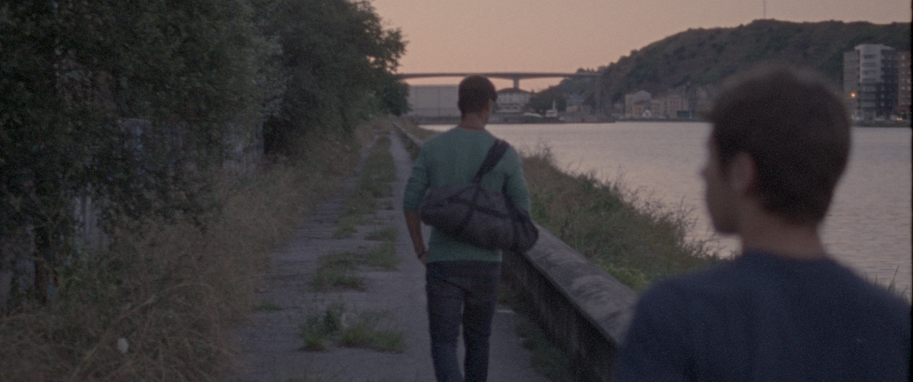
Dawn breaks on a road in southern Spain. At ground level, at more than 100 k.p.h, a lorry speeds along the asphalt. We see, metre by metre, the road fly by. We only see this, metres and metres of road. Ibrahim is hidden- hidden in the Underbelly of the lorry, with only one thing on his mind: his return to Spain. The lorry flies past. Then flies faster. Metres turn into kilometres and we are still there, watching the asphalt race by.

DIRECTOR´S NOTES

“ Hidden away ” is not only a love story. It is a love story, but it wanted to be much more than just this.
After I finished a short film called “Cuando Corres ”, I had the thought that I need to know further. I felt compelled to find out what became of that boy who reached Spain clutched under a truck. How would he be greeted by the authorities, where was he to live, what school would he attend? I needed to know the obstacles such a young boy would have to face, and how he would surpass them.
There was an idea that quite intrigued me: I wanted to know what would happen if a perfectly integrated under aged immigrant-residing in Spain for a while-was informed that he is to be deported soon. What would his reaction be? Where would he go? I was baffled by these questions, but above all I felt the need to research and tell this story.

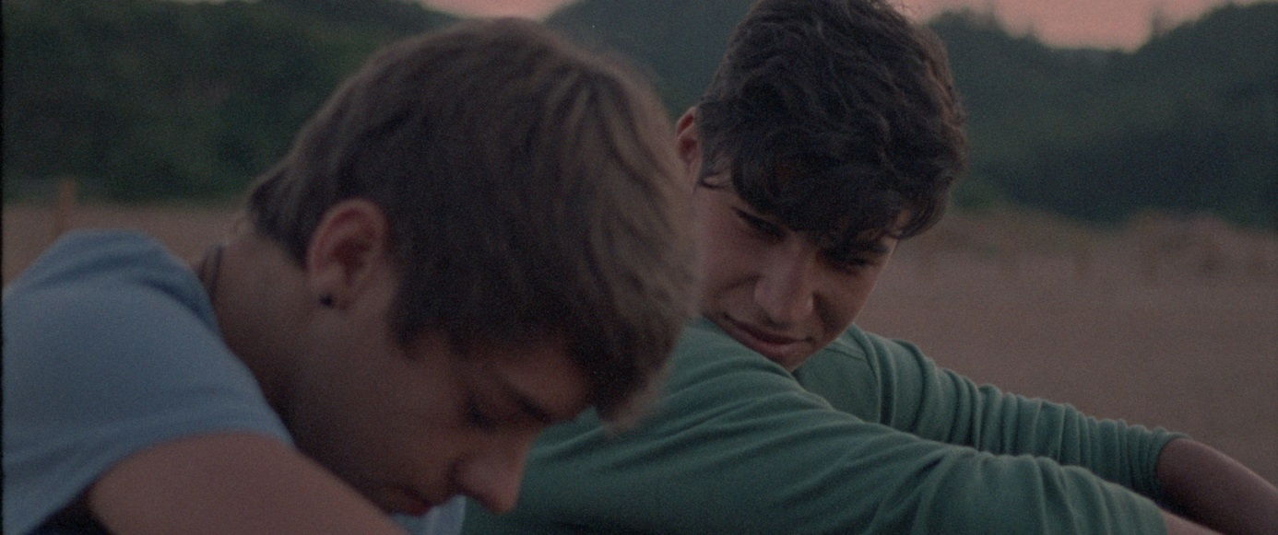
There are many such under-aged immigrants entering our country every day without us even noticing. And whenever we talk about this matter, we deal with it as if it was a problem. However, those minors are the ones in trouble: they have left everything behind-home, family and friends to come over here. And let’s not forget that any problem becomes more acute when you are a minor, for if adults are sometimes unable to face them, a child sees his world turned upside down. That is a problem, a big one. But the beauty of this story is not what might appear initially as the main subject. That is, the secondary plot cannot be regarded as such, because every immigrant, every child, has a story of his own. A different way to perceive and feel the world. And Ibrahim has his. There is always a story behind every drama. This particular one is told by two fifteen-year-old boys, one of them from Morocco, the other one from Spain-who suddenly realize their friendship has evolved into something more, something beyond their control. That is beautiful. You can only live your first true love once. It doesn’t matter whether you are straight or gay, Spanish or Moroccan. And that is the thing, even though at first sight the barriers dividing us all are far too high, there is indeed something that unites humankind: feelings. We all feel. That makes us equals.

“Hidden Away” chronicles men’s equality before feelings. It is irrelevant where you are from, what you have done or what you think. We all feel. That explains why anyone can be identified with this story, because true and pure feelings-love, pain, sorrow, happiness-are the same for all of us. For those who are close to us, and for those who are not.
When I came to writing this story, I wondered what was the best way to structure it would be. I had it clear in my head: I knew what I wanted to tell, where to start and where to end it. But I pushed for something more. I wanted the viewer to feel as restless and lost as the characters.
Ibrahim and Rafa are both completely lost. The first one is in a foreign country, and he is suddenly notified that he is forced to leave. He becomes involved with a gang of cun men. He doesn’t know what to do or where to go. And to top it all, he is having feelings for a boy that he can’t explain. A boy from a different culture. Rafa is equally lost. On the one side of the balance stand his everyday life, his family. On the other one, Ibrahim. The feeling I wanted to convey to the audience was confusion. That explains why the story is sort of disorienting at the beginning. It continuously jumps from present time to the future, and back to the past, leaving the audience breathless, making them feel like they are totally lost. But little by little, the puzzle fits in.

Until the story reaches a more structured and understandable end. The title- ”Hidden away” -has a much deeper meaning than it might appear. In this story, Ibrahim is not the only one to act “hidden away”, running from the authorities not to be arrested and extradited to his country. As a matter of fact, everyone acts “hidden away” to a certain extent. Rafa does it: he is forced to live a secret love
story, hiding his feelings from everyone by fear of the impact they might have on his life. So does Ibrahim, as well as our antagonists - Youssef, Mohammed and the rest of the crowd. Those boys arrived here in exactly the same circumstances as Ibrahim, and for several reasons they have been driven to the dark side. Society rejects them, and they respond by sticking their chests out and acting
outside the law, forsaken and unseen. They steal, fiddle and assault...all of it “hidden away”.
So here are the subjects: immigration and homosexuality.
Both of which-at least in this society-must sometimes be lived “hidden away”. Without anyone noticing. When you are an immigrant, you are unceasingly advised not to stand out from the crowd, or else you will get into trouble and your future in this country will be jeopardized. When you are an immigrant, society expects you to do the dirty work and vanish. The less people know about you, the better.
Just like when you are gay. The premise is exactly the same. Do as you like, but hiding. Don’t stand out. Don’t show your feelings in public, you might offend someone. Don’t you dare kissing another boy in the street. We let you do it, but in private.
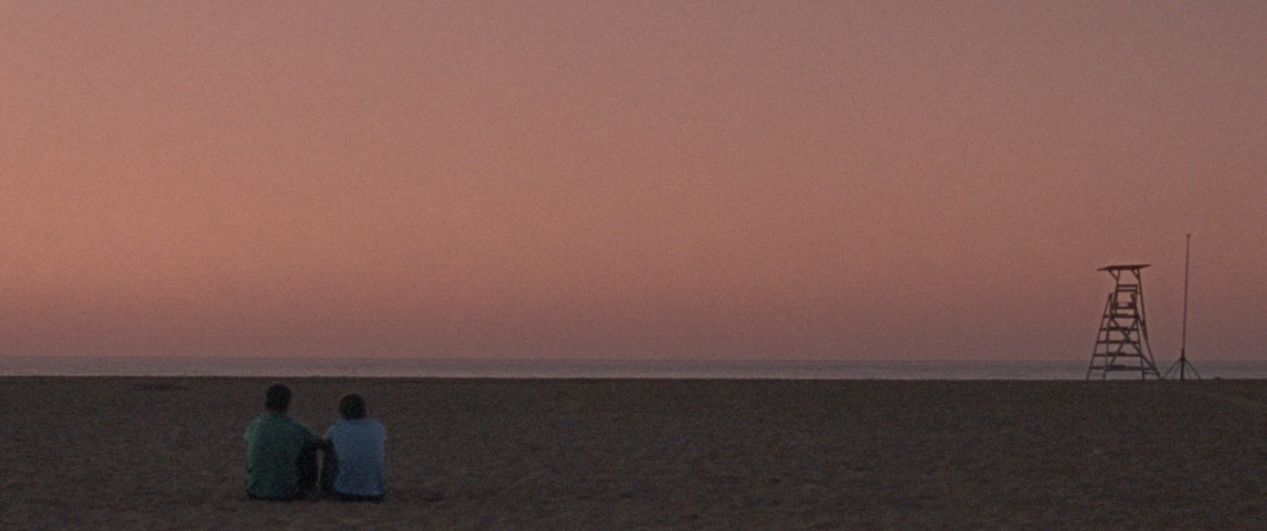
That is how our protagonists live. Hiding their lives from others. Trying not to stand out. Trying to hide what they feel. Living, in a few words, away from others-” hidden away”.
MIKEL RUEDA – DIRECTOR

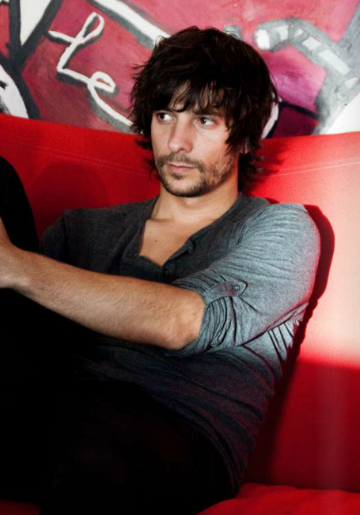
Mikel Rueda, (Bilbao), debuts as a director with “A escondidas”. After completing his studies in Audiovisual Communication, he worked for 4 years in television as producer of the tv-show “Vaya Semanita” (ETB).

After receiving a grant from the Diputación of Vizcaya, he decides to continue his studies at the New York Film Academy, where he shooted, among others, the short “Present Perfect”. With this short Film, Mikel has been awarded in more than 25 international film festivals. The next year, he gets the opportunity to co-direct his first feature film: “Stars that wish upon”, selected in San Sebastian Film Festival. During this years, Rueda decide to keep shooting 2 more short-films, with them he has been selected in more than 150 festivals around the world. Right now he is working in his next feature film project.

FILMOGRAPHY

Feature films:
- A ESCONDIDAS (2014 – Super 16mm)
- ESTRELLAS QUE ALCANZAR (2010 Super 16mm) – Co-director.

Short films:
- AGUA! (2012 – HD)
- CUANDO CORRES (2009-2010 HD)
- PRESENT PERFECT (2007 16mm)
- IN THE LAUNDRY (2006 16mm)
- JUST ONE KISS (2006 16mm)
- HAPPY TOGETHER (2006 16mm)
- STEPPING IN LOVE (2005 16mm)
- ÉRASE UNA VEZ (2004 Betacam Digital)
- EL CARRITO (2003 Betacam Digital)
- NUEVE MILIMETROS (2002 DV-cam)

TECHNICAL DETAILS

ORIGINAL TITLE: A ESCONDIDAS
ENGLISH TITLE: HIDDEN AWAY
WRITTEN & DIRECTED BY: Mikel RUEDA
CAST: German ALCARAZU , Adil KOUKOUH, Joseba UGALDE, Eder PASTOR, Moussa ECHARIF, Mansour ZAKHNINI, Ana WAGENER and Alex ANGULO.
PRODUCED BY: BALEUKO SL & BITART (Main co-producer)
ORIGINAL LANGUAGE: Spanish
RUNNING TIME & FORMAT: 88 MIN & DCP/HD
YEAR OF PRODUCTION: 2014
OFFICIAL WEBSITE: www.aescondidaspelicula.com

CONTACTS

PRODUCERS:
BALEUKO SL
Askatasun Etorbidea 23, bajo
48200. Bizkaia
SPAIN
http://www.baleuko.com

WORLDWIDE SALES:
WIDE
9 Rue Bleue
75009 Paris
FRANCE

